HTML-CSS PRACTICE 06

1. Let's create a dynamic menu like all images bellow

Resource: “deep-menu”

- State 1: structure

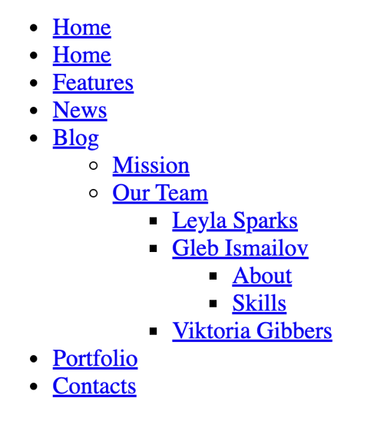

- State 2: fold mode

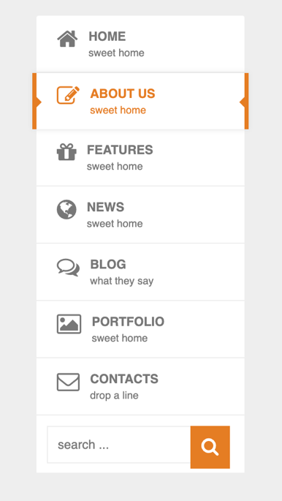

- State 3: hover to “HOME”

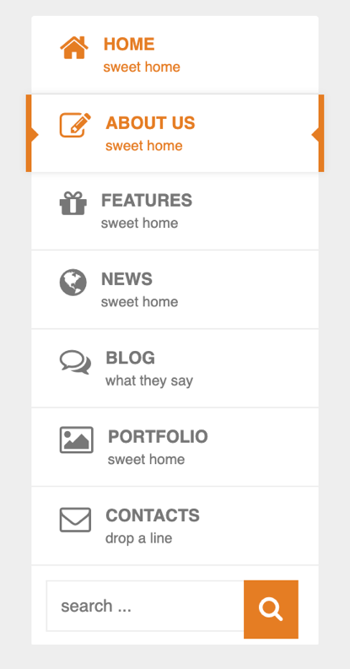

- State 4: hover to “NEWS”

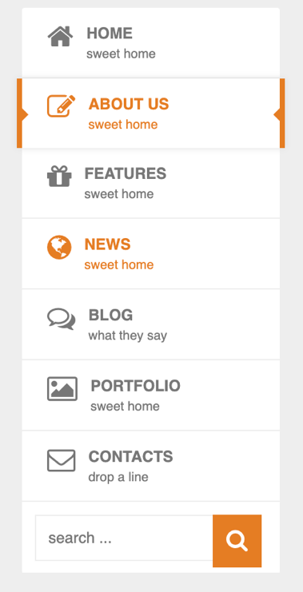

- State 5: hover to “BLOG”



- State 6: hover to “BLOG”, then hover to “Mission”



- State 7: hover to “BLOG”, then hover to “Our Team”

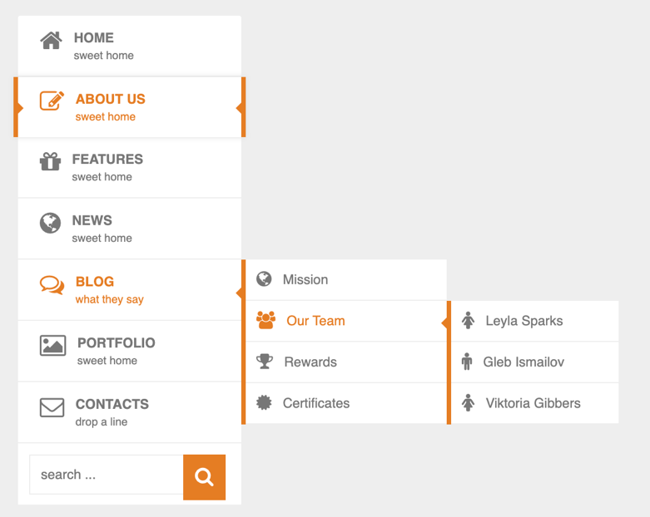

- State 8: hover to “BLOG”, then hover to “Our Team”, then hover to 1 people (Ex “Gleb Ismailov”)

